In New York, Russian oligarchs are yet to be sanctioned

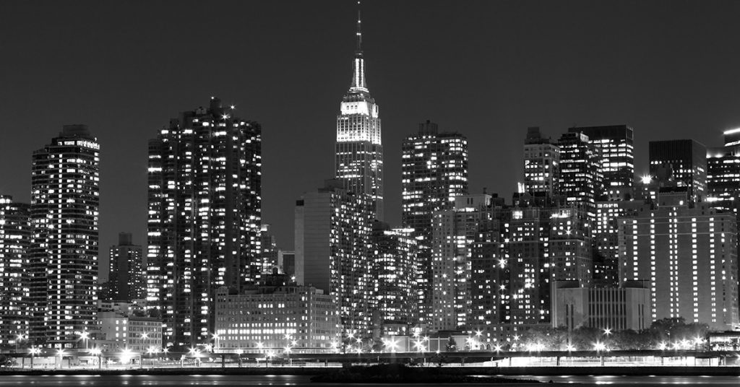

NYC skyline

Joel Konopo

As Russian forces continue their offensive on Ukraine, one of the main side stories is playing out in New York.

Global response has been to sanction Russian oligarchs, and a database of these individuals shows that at least four - out of an unknown number - have substantial holdings in New York and the surrounding area.

Oligarchs are a small group of wealthy aristocrats, especially in Russia, who exercise their privilege for corrupt or selfish means.

The Countering American Adversaries Through Sanctions Act (CAATSA), which imposes sanctions on Russian business people seem not to have frozen property belonging to oligarchs such as Dmitry Rybolovlev, who has amassed wealth in New York and surrounding states - sometimes taking advantage of loopholes in estate tax laws by using complex special trusts to avoid detection.

A 2020 New York Times investigation on real estate shows that the wealthy foreigners have been making multimillion dollar purchases of up-market real estate in New York City with few questions asked.

This is important because taking advantage of a loophole in United States law that fosters the movement of largely untraceable money through shell companies has pushed the price of property in the City. Critics say one of the reasons the City is not affordable to stay in is that wealthy people like Rybolovlev buy expensive property they don’t live in and rent it at high prices.

Among the wealthy foreigners are some Russian oligarchs with business interests in New York City. Rybolovlev is interesting because he seems to be a poster child of Russian president Vladimir Putin through his close links with the former Russian minister of environment. He was only added to the CAATSA list in 2018. It is not clear whether his assets have been frozen at the moment because of the complex and lengthy process involved in actually confiscating property in New York.

For years, oligarchs closely tied to Putin have parked their wealth in high-end properties in locales from New York to Palm Beach; Rybolovlev property in New York is indicative of this larger scheme:

·      In 2011, he acquired a 10-bedroom penthouse near Central Park in Manhattan for a record breaking $88 million.

·      In 2018, he invested around $500 million into biotechnology firm Apple Tree Partners.

·      His other investments in the US include the Maison de L’Amitie in Palm Beach in Florida as well as a villa in Hawaii he bought for $20 million in 2011.

The Open Sanction database shows that Rybolovlev is among the 163 Russian and Belarussian oligarchs on that list who acquired wealth in a controversial manner in Moscow. The Open Sanctions database shows that four oligarchs either live or have connections in New York state and city. Rybolovlev is among them.

In 2010, he sold his controversial potash company for $6.5 billion in Russia and has been using his wealth to exert his global influence, snapping up shares in New York companies and expanding his reach in New York and other parts of the US.

His critics say sanctions by the Biden administration have not been powerful enough to discourage Russia from continuing its assault on Ukraine. They argue that stiffer penalties on oligarchs will pressurize Moscow.

Interestingly, Biden has its own list of Russian oligarchs it says it has sanctioned. A statement from the White House puts the number of sanctioned Russian oligarchs at 140, seizing their wealth. It is not clear whether this is the same database from Open Sanctions.

Open Sanctions is a non-profit organization that provides a database of individuals and companies that are sanctioned in Europe and the US to enable governments to take action against those accused of breaking the law. Beside the real estate in New York, the database shows that Rybolovlev has multiple investments in New York and other parts of the US. He appears in the Open Sanctions database as one of the politically exposed people close to the Kremlin.

Of particular interest is his friendship with Belarusian dictator, Alexander Lukashenka and former Minister of Natural Resources and the Environment, Yuri Trutnev, puts him in close proximity with the Kremlin.

Other oligarchs with substantial investment in New York include former owner of Chelsea soccer team, Roman Abromovich who is connected to New York city real estate, Russian-American oil tycoon billionaire Eugene Shvidler, who reportedly bought a $2.5 million two-bedroom apartment on the Upper East Side at 785 Fifth Avenue in 2018.

Oligarch and businessman Alexei Kuzmichev is also connected to property in the city. The billionaire purchased a pair of neighboring apartments on the Upper West Side [for a combined $57.5 million](https://ny.curbed.com/2016/5/4/11591186/atterbury-mansion-mega-home-buyer-alexei-kuzmichev) five years ago. Another Putin ally, billionaire, Oleg Deripaska, who made his money in the aluminum business, has been connected to a townhouse [in Manhattan’s Greenwich Village at 12 Gay Street](https://nypost.com/2022/02/27/heres-where-russian-oligarchs-and-their-families-own-property-in-nyc/).

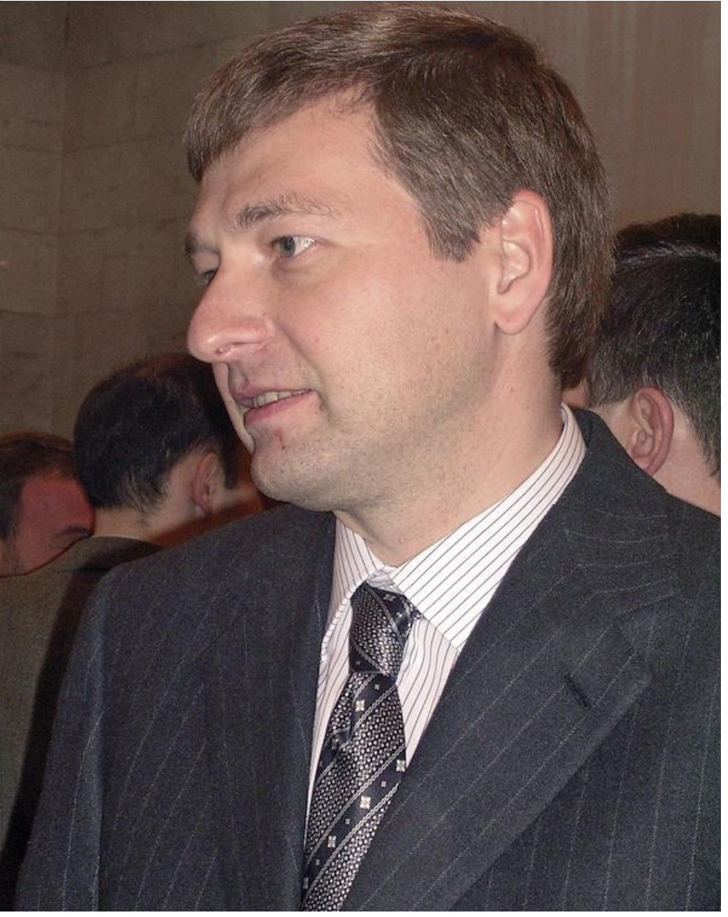

Rybolovlev in 2006, pic by Ilya Zaslavskiy

Rybolovlev has also been the subject of court cases in New York city. In the divorce proceedings in 2014, the Supreme Court of New York County, his wife, Elena Rybolovlev, claimed that her husband created opaque trusts and used them to purchase New York property. Elena Rybolovlev said in court papers that her husband created two trusts known as Virgo and Aries to which he transferred interests from multiple companies, in an effort to exclude his assets from his wife. Ryboloblev denies the claim.

As an indication of how well-clocked shell company and Trust ownership is, Times said they took more than a year to unravel ownership of shell companies with condos in the Time Warner Center, by searching business and court records from more than 20 countries and interviewing dozens of people with close knowledge of the complex, examining hundreds of property records and connecting the dots from lawyers or relatives named on the deeds to the actual buyers.

One of Kremlin’s critics, former Russian politician and anti-corruption advocate, Ilya Zaslavskiy said Rybolovlev uses his wealth to erode democracy around the world.

“The fact that Rybolovlev managed to penetrate French, Monegasque, Cypriot and Swiss political establishment and neutralize their national legal systems makes him a relevant candidate for sanctions,” said Zaslavskiy in an interview, adding: “It is also alarming that such controversial figure is so active in the US, and even benefiting from American state funds.”

Zaslavskiy said Rybolovlev has eroded legal institutions in several key Western jurisdictions because he has vast financial wealth.  In his view, the US legal system is the only one that can take head on people as powerful as Rybolovlev.

 “Some of the facts about Russian oligarchs are not new, but have been neglected by US policy-makers.”

President of the Ukrainian Institute of America, Pat Singer said the non-profit organization based in Queens, New York has a committee that briefs US policy-makers about the oligarchs influence on the Kremlin. The Institute also works with moderate Russian pressure groups in New York and Moscow to apply pressure on oligarchs to cut ties with the Kremlin, Singer explained.

She expressed concern on what she said was inadequate enforcement to act against oligarchs listed on the CAATSA.

“Rybolovlev is sanctioned under the CAATSA, but there is no real impact on his business as far as we know,” she said without elaborating.

 Singer lived in Moscow in the early 2000s and explains that Rybolovlev’s relationship with Moscow is historic.

“While we don’t have a problem with that, we are worried that the US is allowing him to undermine our democracy. This is disturbing.”